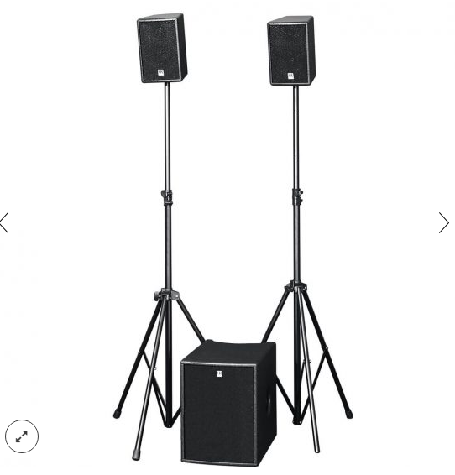

LUCAS SMART
EVP/SRP*:
*empfohlener Verkaufspreis / Suggested Retail Price
This product from our product archive is no longer available to order.
This product is not currently available.

Powered PA system with 410 watts total output (250 W for the sub; 2 x 80 W for the satellites), 10″ subwoofer with castors, 2 satellites each with a 6.5″ speaker and 1″ dome tweeter, HK AUDIO Micro Tilt, 2x XLR In, 2x Cinch, 2x XLR Through, 2x Cinch, 2x Speakon Satellite Out
Merkliste
E-Mail

- Description

- Techn. Data

- Downloads

Techn. Data

LUCAS SMART
Model | LUCAS Smart
Product Class | LUCAS - The next Generation
Frequency response +/- 3 dB | 43 Hz - 19 kHz
Power Rating | 410 W
Amplifier | Class D
Active protection circuits | Opto-Limiter, Dynaclip Limiter
LF Speaker | 1x 10" Neodymium
Low/Mid Speaker | 2x 6,5"
HF Driver | 2x 1"
Connections | 2x XLR In,2x Cinch, 2x XLR Through,2x Cinch,2x Speakon Satellite Out
Pole mount | MicroTilt™, 15 mm
Optional accessories | HK Audio Speaker Stand Add-On, HK Audio Protection Cover
Weight | 30 kg / 66 lbs.

